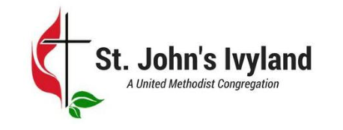  820 Almshouse Road  Ivyland, PA 18974  (215) 357-6998  stjumc@aol.com  www.StJohnsIvyland.com | 820 Almshouse Road  Ivyland, PA 18974  (215) 357-6998  stjumc@aol.com  www.StJohnsIvyland.com
820 Almshouse Road  Ivyland, PA 18974  (215) 357-6998  stjumc@aol.com  www.StJohnsIvyland.com | 820 Almshouse Road  Ivyland, PA 18974  (215) 357-6998  stjumc@aol.com  www.StJohnsIvyland.com
820 Almshouse Road  Ivyland, PA 18974  (215) 357-6998  stjumc@aol.com  www.StJohnsIvyland.com | 820 Almshouse Road  Ivyland, PA 18974  (215) 357-6998  stjumc@aol.com  www.StJohnsIvyland.com
820 Almshouse Road  Ivyland, PA 18974  (215) 357-6998  stjumc@aol.com  www.StJohnsIvyland.com | 820 Almshouse Road  Ivyland, PA 18974  (215) 357-6998  stjumc@aol.com  www.StJohnsIvyland.com
820 Almshouse Road  Ivyland, PA 18974  (215) 357-6998  stjumc@aol.com  www.StJohnsIvyland.com | 820 Almshouse Road  Ivyland, PA 18974  (215) 357-6998  stjumc@aol.com  www.StJohnsIvyland.com

